Identifying Learning Disabilities in Children using Informal Educational Assessment Tools

Tanvi Penumudy (E18CSE187)  
Computer Science and Engineering  
Bennett UniversityGreater Noida, Uttar Pradesh, India  
tp6145@bennett.edu.in

lTatineni Mahalaxmi (E18CSE214)  
Computer Science and Engineering  
Bennett UniversityGreater Noida, Uttar Pradesh, India  
tr2648@bennett.edu.in

*Abstract*— ‘Learning Disability’ (abbr. LD) is an inclusively generalized label which encompasses children with difficulty in displaying one or more skills or in processing certain information which is not considered to be a heavy task for a normal child of the same age group. One of the many frequently practiced and established criteria to identify learning disabilities in children in the manually proposed system is by utilizing the ‘Informal Educational Assessment Tools’ such as the Schonell’s Spelling Test, Wepman’s Auditory Test, Burt’s Reading Test, Auditory Sequential Memory Test, Comprehensive Understanding Test, etc. The project focuses on automating the entire process of identification of learning disabilities by means of pre-established machine and deep learning techniques on the information obtained from the integration of the diversely explicated assessment tools. A total of five classification models and three regression models have been proposed to overcome the problem of LD detection over five varying tests to measure differences in learning. The purpose of the project is to simplify and improve the process of detection undertaken by special educators/ remedial trainers, not to substitute, but to supplement the existing methodology in the proposed system.

Keywords—Learning Disability, Neural Network, Decision Tree, SVM, Ensemble Model

# Introduction

The sole motivation behind the idea of the project is to create cognizance of the partially aware concept of LD and to tackle a real-world problem under the hood of ‘Special Education’ which focuses on providing children with identified learning disabilities personalized instruction and support specifically designed to address their unique learning requirements and needs which often go unnoticed in the traditional teaching process, intending to help them overcome their individual differences and rise to their maximum potential [1].

The first and the foremost step in this process is to identify children with LD which serves as the problem statement to this project. Detecting the nature and combination of existence of learning disabilities could sometimes be a strenuous task [6]. In practice, it is difficult to determine if the child in actuality possesses these difficulties or if it is the result of the natural process of growing [7]. In most cases, if these are not taken care of at the right age, could lead to higher disorders such as Dyslexia, Dysgraphia, Dyscalculia, ADHD, etc on the long run [2]. This makes the identification of learning disabilities in children an inevitable non-trivial process.

The term ‘Learning Disability’ shall not be mistaken to be any form of intellectual delay in a child. Learning disabilities are often interchangeably used with the term ‘Learning Difficulties’ that closely relates to one or more combinations of differences in learning. Some of these include difficulty with writing, reading, language, reasoning, mathematics, attention, memory, sequencing, visual discrimination, auditory discrimination, etc. [13]

In a study conducted in the USA, it has been determined that as many as one in every ten children have one or more disabilities in learning. These children either receive special education in their schools or additional support in any form from elsewhere [4]. However, in India, these stats are not clear but special education support units have been set up in most private and public schools in addition to two thousand five hundred special schools, NGOs, and private organizations to address these majorly prevailing issues once identified [9]. By stating these facts, it is evident how crucial and demanding it is to identify learning disabilities which also serves as the motivating factor for the implementation of this project.

Introducing machine and deep learning techniques into the procedure of identification of learning disabilities, offers the benefit of making absolutely no presumptions regarding the nature of data obtained from the subject during the process and helps in removing the element of bias which otherwise exists naturally when the process is solely undertaken by humans [10]. This also reduces the complexity of diagnosis in the manually proposed system by eliminating time and situational constraints which explicitly require the involvement of an experienced/well-trained Special Educator/ Remedial Trainer and physical resources such as remediation tools, flashcards, etc. [8].

Although, the correspondence of LD with the nature and selection of assessments is subject to the currently ongoing research and available data, the robust mathematical background of the variety of machine and deep learning techniques ensures one’s trust to differentiate children on the basis of the broad and complicated set of observations obtained from the driving data [3].

It is difficult to quantify the entire process of learning into certain attributes that represent it. However, extensive research has helped in figuring out certain criteria that might come in handy to understand and determine the nature and combination of existence of learning disabilities [11]. Using assessment criteria such as the ‘Informal Educational Assessment Tools’ as the basis of identification and inference for the customized algorithm or model to work on serves as an innovation in itself.

The salient features and the principal contributions of this paper include:

#### 1) LD Detection utilizing Informal Educational Assessment Tools – Utilizing the data obtained by virtue of informal educational assessment tools from public forums and private student archives as elaborated in Section III.

#### 2) Automating Assessment Tools – Automating the otherwise manual assessment tools in the traditional process is a novelty in itself which is as intricated in Section IV. This offers the benfit of making no foregoing premises and withdraws the natural element of bias.

#### 3) Proposed Models in Predicting Test Results – A total of five classification models and three regression models have been proposed to achieve close to accurate results over five tests of varying complexities measuring a child’s abilities along with their differences in learning (if any) as elucidated in Section IV.

#### 4) Comparative Analysis – A variety of models have been compared and contrasted with one another in terms of training and validation accuracy/RMSE as illustrated in Section V.

# Related Works

It is important to note that there are a relatively low number of research and publications that have been developed and undertaken in the AI domain coming to the field of special education and learning disabilities. It is clear from the given literature that the models proposed are clearly not unique and vary in accordance with the nature of the data obtained subject to the diverse range of attributes.

Loizou et al. (2011) [1], stated how machine learning techniques can be utilized to develop remediation tools by finding an optimal set of independent attributes that represent differences in learning. Nugent et al. (2009) [18] elucidated how clustering a capability matrix can help in differentiating children with different skill sets. Donetti et al. (2016) approached the problem of detecting dyslexia in its developmental stages using SVM.

Mary et al. (2017) [2] proposed a systematic approach to feature reduction and feature selection with the measure of confidence while using an AGA and performing classification using a Markov Model and a DNN. Sabu et al. (2015) [16] cited the role of hybrid feature selection for determining LD cases.

Mary et al. (2013) [4] emphasized on data mining techniques and their application in identifying LD in children. In addition to this, Mary et al. (2017) [5] threw light on data mining techniques for determining LD. Saraswathi et al. (2018) [11] focused on data mining and the importance of assistive technology in the assessment process.

David et al. proposed and elaborated on various techniques for prediction of LD in the due course of their study in a series of publications. David et al. (2010) [7] signified various classification techniques for the purpose of identification of LD. David et al. (2011) [6] proposed a decision tree classifier and an SVM classifier to classify children on the basis of LD. Fuzzy Systems David et al. (2013) [9] proposed a technique to improve performance in a neuro fuzzy/ fuzzy system to identify LD. David et al. (2014) [8] analysed ANFIS and ANN for detecting LD. David et al. (2011) [12] stated an approach to predict LD using RST emphasizing on data mining with a comparative study of the SMO algorithm which serves as an interesting read.

Wu et al. (2006) [13] foregrounded the use of ANN and SVM. Mounica et al. (2019) [14] made use of an ensemble learning framework for identifying LD in children. Hassiem et al. (2013) [15] did a comparative study involving ANN and SVM in diagnosing students with handwriting troubles.

Chakraborty et al. (2019) [10] explored potential machine learning technologies that could be utilized for the purpose of predicting LD in children. Julie et al. (2012) [19] elaborated on imputation and reduction of attributes with ANN in determining LD. Julie et al. (2010) [17] proposed the usage of Decision Trees in predicting LD in children.

# Data Analysis

A total of five datasets have been utilized for the purpose of study. The Schonell’s Spelling Test and the Burt’s Reading Test dataset have been obtained from the United Kingdom Mental Health Services and LD Stats Website. The datasets used for WADT (Wepman’s Auditory Discrimination Test), Digit Span and Comprehensive Understanding Test have been originally obtained from the student archives of private institutions such as Ambitus International School, GIIS and Canary International School in and around Hyderabad, Telangana during the years 2013 – 2019.

The underlying conjecture behind the idea is that a child with one or more combinations of differences in learning can be identified from the information obtained from a minimal set of tests performed in the given time. The study undertaken in this paper relies upon the assumption that the subjects who took part in the process of collection of data solely represent the entirety of the student population and the established assessment tools efficiently measure the learning abilities of the participating candidates in that particular domain (Reading, Spelling, Sequencing, Memory, Auditory Discrimination, Comprehensive Understanding).

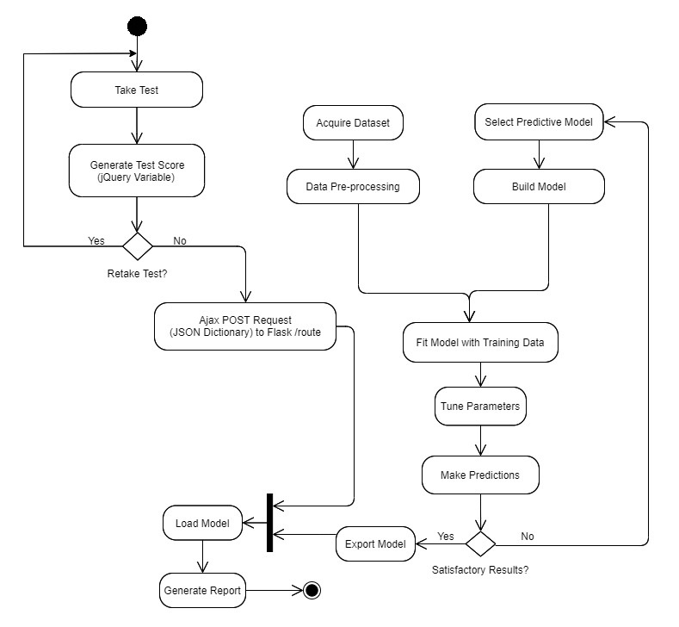

Table I. Performance Level

|  |  |  |
| --- | --- | --- |
|  | Performance Level | Review |
| 1 | Severe | Needs Remediation |
| 2 | Mild | Observation Required, Needs to Review after 1 Year |
| 3 | Average/Neutral | Performing on an Average Level |
| 4 | Good | Performing Above Average |
| 5 | Well | Performing Really Well |

## Schonell’s Spelling Test Dataset

The dataset comprises of 33,936 entries of children who have undertaken the test. It contains the child’s biological age (in years and months), gender, Schonell’s test score, spelling age (in years and months) and the level of disability (Severe/ Mild/ Average/ Good/ Well) – Table I. The test requires a child to write the spellings of words one at a time that are read aloud by the simulation wherein the test score is generated after 10 mistakes made (Need not be consecutive).

## Burt’s Reading Test Dataset

Burt’s Reading test dataset consists of 39676 entries of children who have taken this test. The Dataset comprises of the child’s biological age (in years and months), gender, Burt’s test score, reading age (in years and months) and the level of disability (Severe/ Mild/ Neutral/ Good/ Well) – Table I. In this test, the child is required to read aloud the words displayed on the screen one by one wherein the test score is generated after 10 mistakes made (Need not be consecutive).

## Wepman’s Auditory Discrimination Test (WADT) Dataset

The dataset of WADT consists of 80 children who have undertaken the test. WADT requires a child to identify subtle differences or similarities between 40 pairs of commonly used words, hence designed specifically to measure his/her Auditory ability/disability. The dataset consists of the child’s gender, WADT test score and a column with binary entries - either Yes (for Auditory Disability) or No (for no Disability).

## Auditory Sequential Memory Test (Digit Span) Dataset

The dataset of the ASM Test comprises of 3360 entries of children who have taken the test. The ASM Test measures the child’s ability to sequentially memorize digits in both forward as well as backward span. The dataset comprises of the child’s biological age (in years and months), gender, digit span/ ASM test score, digit span/ ASM test age (in years and months), and the level of disability (Severe/ Mild/ Neutral/ Good/ Well) – Table I. The final test score is the addition of the individual test scores of forward and backward span generated after two mistakes of each of these tests.

## Comprehensive Understanding Test Dataset

The dataset of Comprehensive Understanding test consists of 246 entries of children who took the test. The dataset consists of attempted passage number, test score, time taken and column with entries – Yes/ No/ Mild – Table-I which corresponds to the comprehensive understanding difficulty of the child. In this test, the child is given a comprehension in accordance with his/her grade as entered in the details section. He/ She requires to attempt a list of 4-5 multiple-choice questions after reading and understanding the given passage.

# Proposed Method

The section has been divided into two sub-sections. The first sub-section elucidates the various data preprocessing techniques used. It is a crucial step since the efficiency of the algorithm used significantly depends on it. The latter sub-section deals with the models employed to identify the learning disabilities in children and their performance in each test performed.

## Data Preprocessing

## Obtaining Inference Data

### Data Transformation: The dataset pertaining to Schonell’s, Burt’s and ASM Digit Span Test contains two distinct columns for the child’s age. If the child’s age (Biological Age/ Test Age) is X years and Y months, the entries of these columns are X and Y respectively. Before training the regression models for three of these tests, we have transformed these columns into a single column with the entry X*12+Y that corresponds to the child’s total age in months.

### Data Reduction: In Schonell’s, Burt’s and the ASM Test, it has been observed that the feature ‘Gender’ has the least impact on the target class in case of classification. (low correlation), hence it has been excluded from predicting the target class.

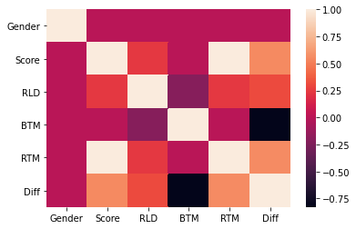

Fig. 1. Correlation Analysis of Burt’s Reading Test Data

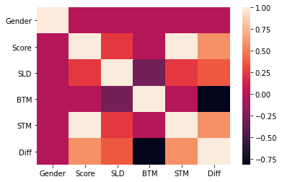

Fig. 2. Correlation Analysis of Schonell’s Spelling Test Data

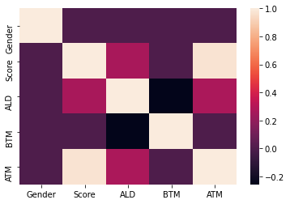

Fig. 3. Correlation Analysis of ASM Test Data

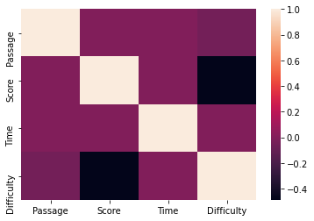

Fig. 4. Correlation Analysis of Comprehensive Understanding Test

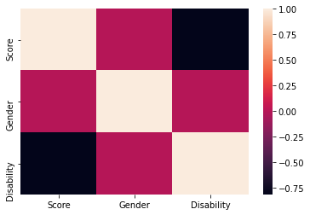

Fig. 5. Correlation Analysis of WADT Data

### Feature Scaling: A Min-Max Scaler from the Sklearn Preprocessing Library has been used to scale the column entries between 0 and 1.

## Proposed Models

### Schonell’s and Burt’s Test

#### Classification: A six-layered Deep Neural Network of the following architecture seemed to be the best solution for predicting the target class of both Schonell’s and Burt’s Test (i.e the Performance in these tests) with a decent accuracy on both Training and Validation sets with 100 epochs each.

#### Regression: The same architecture which when modified to predict a continuous value on metrics such as mse gave rise to a minimal rmse while predicting Spelling Age in Schonell’s Spelling Test and Reading Age in Burt’s Reading Test (in months) with an increased number of epochs from 100 to 500

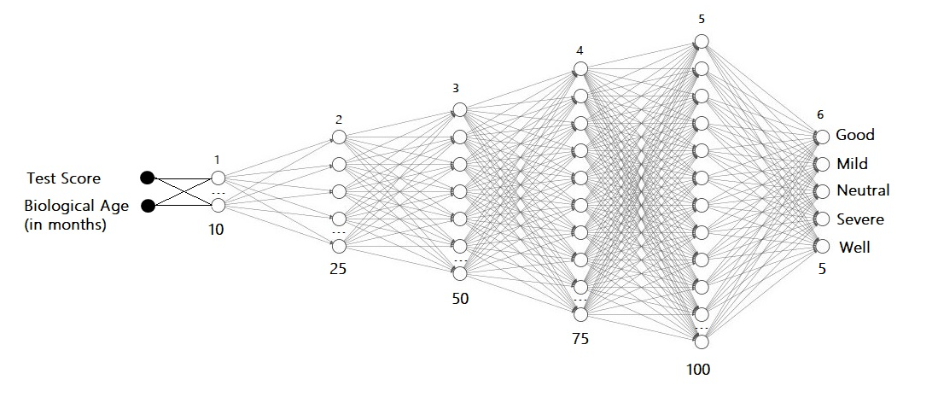

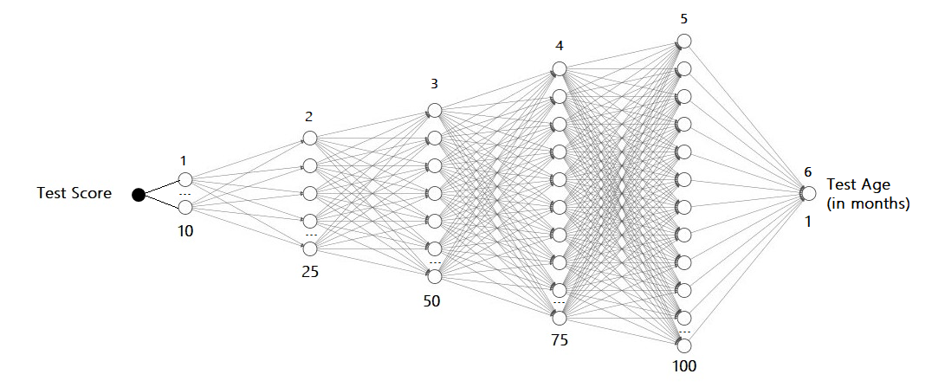

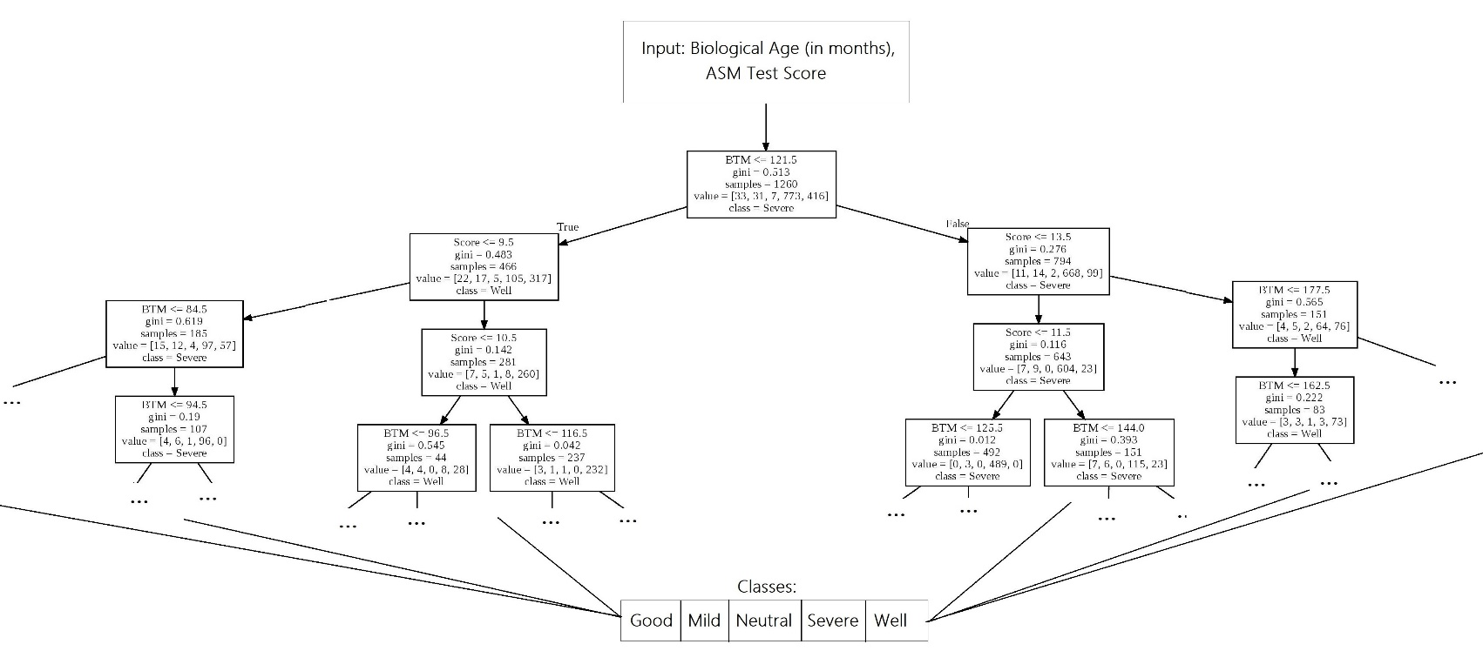

### WADT

*Classification:* After experimenting a good number of models, it has been observed that a Support Vector Machine (SVM) Classifier worked extremely well on the WADT Data. The classifier had a total of 24 Support Vectors. The Data was linearly separable with a single one-dimensional hyper plane (line) built to separate the two classes using the Classifier in two-dimensions. In Fig. 6, the X-axis corresponds to the Target Class – Auditory Disability that has binary entries – either Yes (yellow) or No (red), while the Y-axis corresponds to the gender of the child – Female (1) or Male (0).

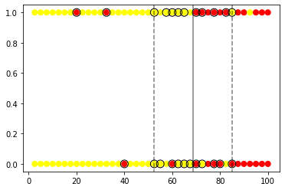

Fig. 6. SVM Classifier Linearly Separating the Data in 2D with the Support Vectors – (32.5, 1), (82.5, 1), (77.5, 1), (20, 1), (80, 0), (70, 1), (40 0), (77.5, 0), (85, 0), (70, 0), (60, 0), (72.5, 1), (57.5, 1), (65, 0), (65, 1), (55, 0), (52.5, 1), (67.5, 0), (52.5, 0), (62.5, 0), (72.5, 0), (62.5, 1), (60, 1), (85, 1)

### Auditory Sequential Memory Test (Digit Span)

#### Classification: A Decision Tree Classifier with the criterion of splitting as gini impurity with minimum sample split as two and minimum sample leaf as 1 has been proposed to classify if a child has Auditory Disability or not on the basis of ASM Test data.

#### Regression: A Decision Tree Regressor has been used to predict the ASM Age.

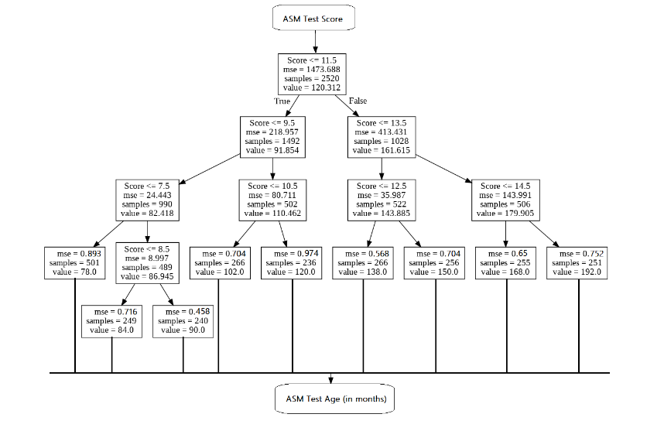

### Comprehensive Understanding Test

#### Classification: An Ensembled Model has been adopted to classify if the child has Comprehensive Understanding Difficulty or not. It is a technique where in 2 or more associated weak analytical classifiers are utilized to synthesize a composite score aiming to enhance the accuracy. The model is an ensemble of SVM Classifier, Logistic Regression, Decision Tree Classifier and KNN Classifier.

#### The Ensemble Model gave impressive results which when tested on Training and Validation set in constrast to individual usage of the classifiers overcoming individual limitations such as bias and variance which heavily affect the reliability of the predicted observations.

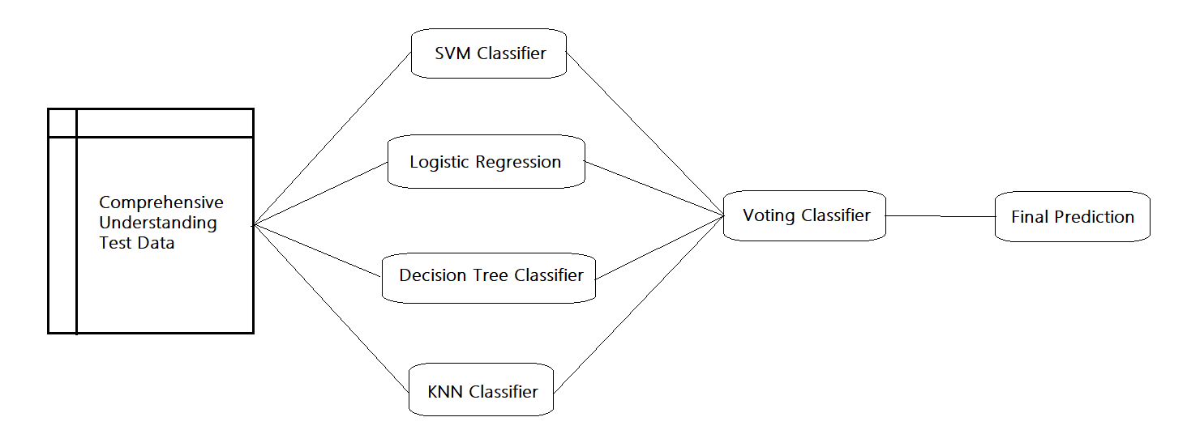

# Results and Discussion

In the end of the Informal Educational Assessment, a test report is generated in pdf format that could be downloaded any time. Table I and Table II describe the analytical findings generated in the report along with their Accuracies and RMSE in Classification and Regression Models respectively.

Table I. Classification

|  |  |  |  |  |  |  |
| --- | --- | --- | --- | --- | --- | --- |
| Dataset | Dataset Shape | Source | Target Class | Model Used | Training Accuracy | Validation Accuracy |
| Burt’s Reading Test Data | 39676x7 | Source1 | Performance  (Severe, Mild, Average, Good, Well) | Deep Neural Network | 98.59% | 96.67% |
| Schonell’s Spelling Test Data | 33936x7 | Source1 | Performance  (Severe, Mild, Average, Good, Well) | Deep Neural Network | 98.74% | 95.77% |
| Wepman’s Auditory Discrimination Test Data | 80x3 | Source2 | Auditory Disability  (Yes, No) | SVM Classifier | 100% | 97.60% |
| Comprehensive Understanding  Test Data | 246x4 | Source2 | Comprehensive Understanding Difficulty  (Yes, Mild, No) | Ensemble Model 3 | 100% | 99.67% |
| Auditory Sequential Memory  (Digit Span) Data | 3360x7 | Source2 | Performance  (Severe, Mild, Average, Good, Well) | Decision Tree Classifier | 100% | 96.90% |

Table II. Regression

|  |  |  |  |  |  |  |
| --- | --- | --- | --- | --- | --- | --- |
| Dataset | Dataset Shape | Source | Target | Model Used | Training  RMSE | Validation  RMSE |
| Burt’s Reading Test Data | 39676x7 | Source1 | Reading Age  (in months) | Deep Neural Network | 0.72 | 1.24 |
| Schonell’s Spelling Test Data | 33936x7 | Source1 | Spelling Age  (in months) | Deep Neural Network | 0.63 | 0.82 |
| Auditory Sequential  Memory  (Digit Span) Data | 3360x7 | Source2 | ASM Age  (in months) | Decision Tree Regressor | 0.84 | 1.87 |

1 UK Mental Health Services and Learning Disability Services (Online Data Source)

2 Archives of Canary International School, Ambitus International School, GIIS (Global Indian International School), Hyderabad (Offline Private Data Sources)

3 (SVM Classifier, Logistic Regression, Decision Tree Classifier, KNN Classifier)

## Schonell’s Spelling Test

After examining a good number of models and experimenting with their hyperparameters (Table II, Fig. 3), we have arrived at a Neural Network with the proposed architecture in Section IV B.1 for classification and Section IV B.2 for regression

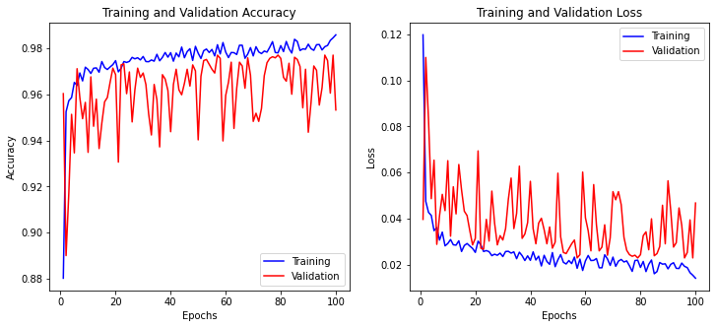



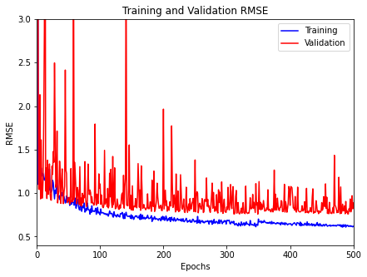

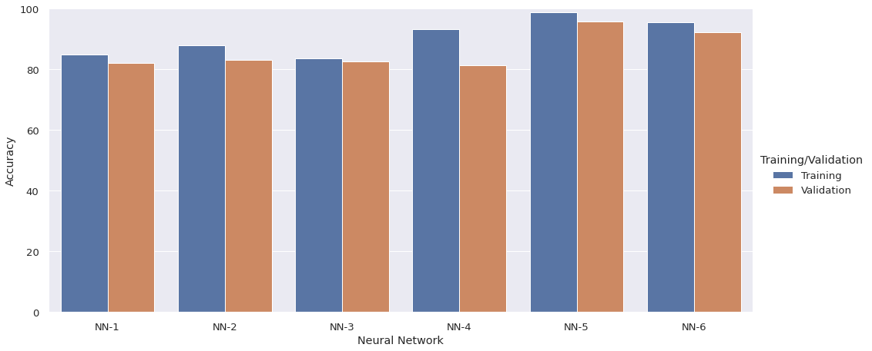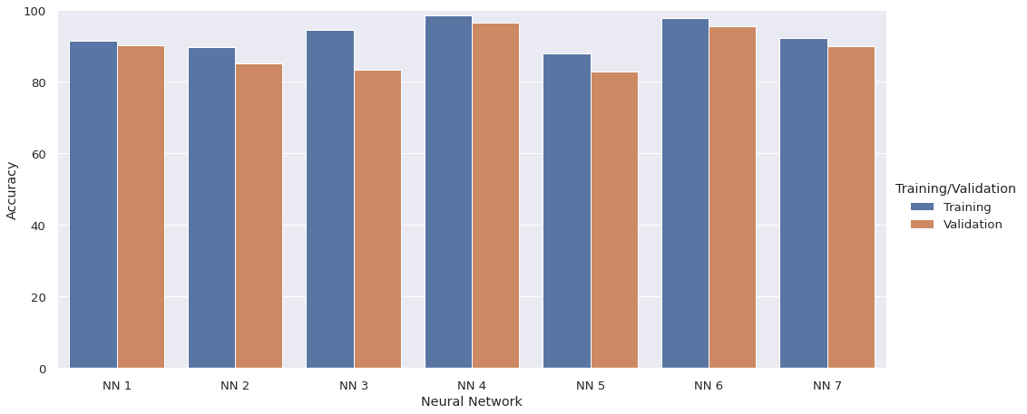

|  |  |  |  |  |
| --- | --- | --- | --- | --- |
| Neural Network | Layers (Excluding Output Layer) | Epochs | Training Accuracy | Validation Accuracy |
| NN 1 | 3 Layers (32, 64 Nodes) | 100 | 84.89 | 82.01 |
| NN 2 | 3 Layers (75, 100 Nodes) | 100 | 87.91 | 83.25 |
| NN 3 | 4 Layers (25, 50, 75 Nodes) | 100 | 83.54 | 82.59 |
| NN 4 | 5 Layers (32, 64, 128, 256 Nodes) | 100 | 93.19 | 81.25 |
| NN 5 | 6 Layers (10, 25, 50, 75, 100 Nodes) | 100 | 98.74 | 95.77 |
| NN 6 | 7 Layers (10, 25, 50, 75, 100, 125 Nodes) | 100 | 95.66 | 92.26 |

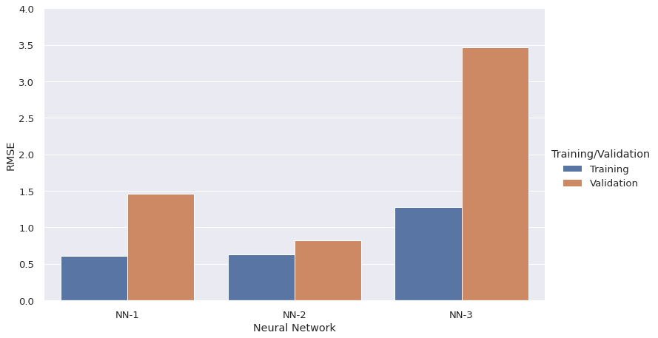

|  |  |  |  |  |
| --- | --- | --- | --- | --- |
| Neural Network | Layers (Excluding Output Layer) | Epochs | Training RMSE | Validation RMSE |
| NN 1 | 4 Layers (50, 75, 100) | 500 | 0.61 | 1.46 |
| NN 2 | 6 Layers (10, 25, 50, 75, 100 Nodes) | 500 | 0.63 | 0.82 |
| NN 3 | 3 Layers (75, 100 Nodes) | 500 | 1.28 | 3.47 |

## Burt’s Reading Test

After examining a good number of models and experimenting with their hyperparameters (Table I, Fig. 2), we have arrived at a Neural Network with the proposed architecture in Section IV B.1 for classification and Section IV B.2 for regression.

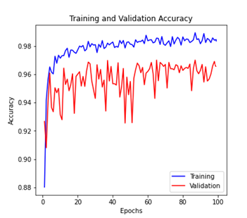

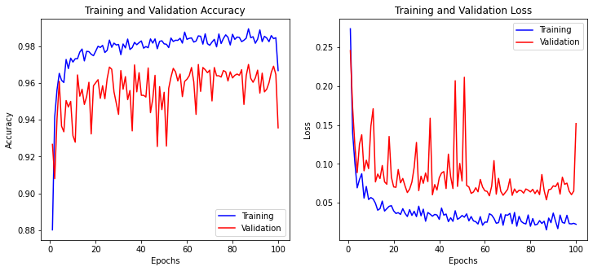

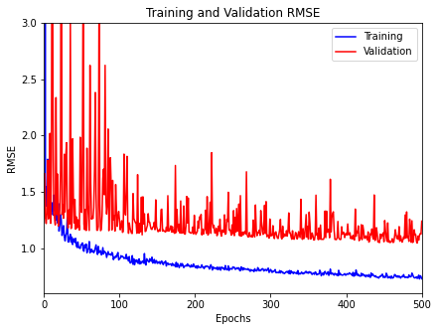

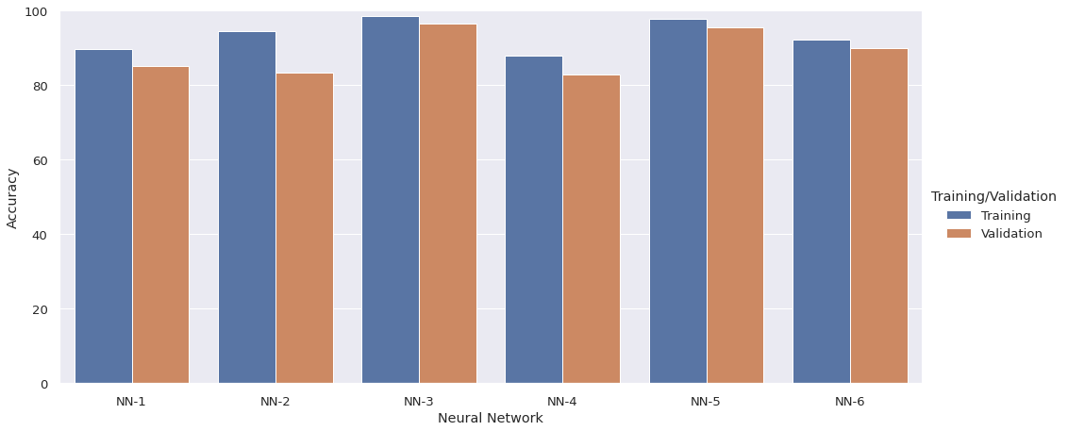

|  |  |  |  |  |
| --- | --- | --- | --- | --- |
| Neural Network | Layers (Excluding Output Layer) | Epochs | Training Accuracy | Validation Accuracy |
| NN 1 | 3 Layers (75, 100 Nodes) | 100 | 89.77 | 85.05 |
| NN 2 | 4 Layers (50, 75, 100 Nodes) | 100 | 94.60 | 83.45 |
| NN 3 | 6 Layers (10, 25, 50, 75, 100 Nodes) | 100 | 98.59 | 96.67 |
| NN 4 | 5 Layers (32, 64, 128, 256 Nodes) | 100 | 88.00 | 82.99 |
| NN 5 | 7 Layers (10, 25, 50, 75, 100, 125 Nodes) | 100 | 97.75 | 95.67 |
| NN 6 | 6 Layers (25, 50, 75, 100, 125 Nodes) | 100 | 92.38 | 89.87 |

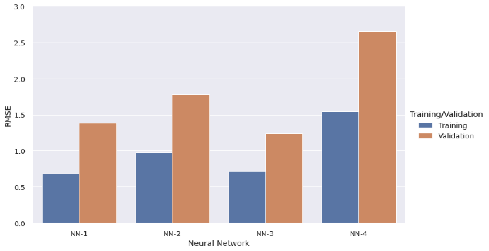

|  |  |  |  |  |
| --- | --- | --- | --- | --- |
| Neural Network | Layers (Excluding Output Layer) | Epochs | Training RMSE | Validation RMSE |
| NN 1 | 3 Layers (75, 100 Nodes) | 500 | 0.68 | 1.38 |
| NN 2 | 4 Layers (50, 75, 100 Nodes) | 500 | 0.97 | 1.78 |
| NN 3 | 6 Layers (10, 25, 50, 75, 100 Nodes) | 500 | 0.72 | 1.24 |
| NN 4 | 6 Layers (25, 50, 75, 100, 125 Nodes) | 500 | 1.54 | 2.65 |

## Wepman’s Auditory Discrimination Test (WADT)

We have arrived at an SVM Classifier (Section IV B.2) after experimenting different models (Fig. 3)

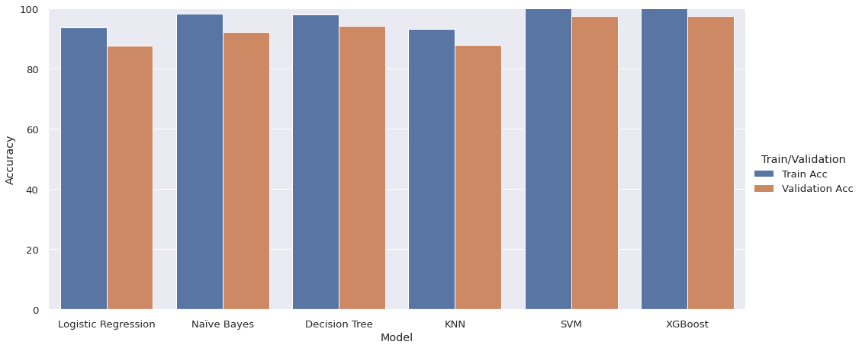

|  |  |  |
| --- | --- | --- |
| Model | Training Accuracy | Validation Accuracy |
| Logistic Regression | 93.82 | 87.68 |
| Naïve Bayes | 98.29 | 92.21 |
| Decision Tree Classifier | 98.05 | 94.16 |
| KNN Classifier | 93.17 | 88.01 |
| SVM Classifier | 100 | 97.598 |
| XGBoost | 100 | 97.596 |

## Auditory Sequential Memory Test (Digit Span)

We have arrived at a Decision Tree Classifier (Section IV B.3) after experimenting different models (Fig. 4)

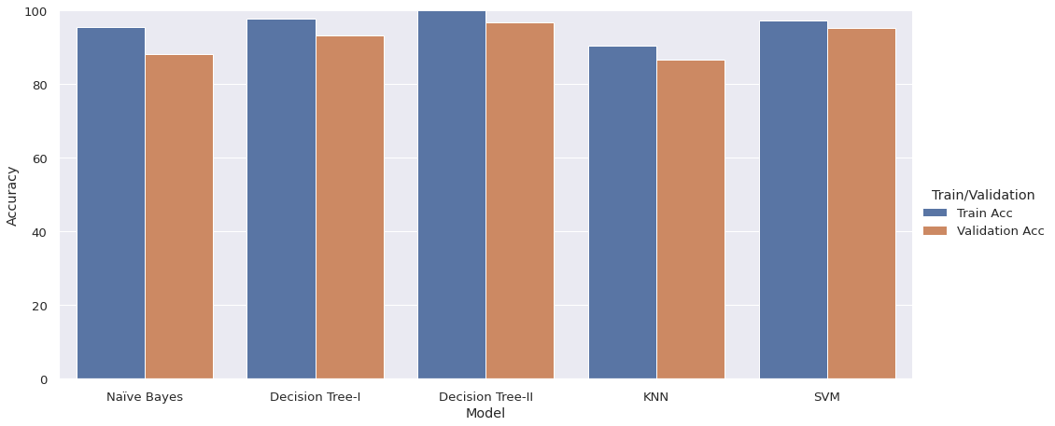

|  |  |  |
| --- | --- | --- |
| Model | Training Accuracy | Validation Accuracy |
| Naïve Bayes | 95.66 | 88.19 |
| Decision Tree Classifier - I | 97.78 | 93.18 |
| Decision Tree Classifier - II | 100 | 96.90 |
| KNN Classifier | 90.56 | 86.61 |
| SVM Classifier | 97.37 | 95.30 |

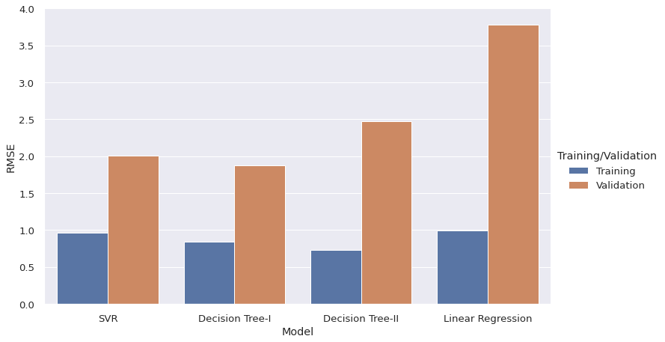

|  |  |  |
| --- | --- | --- |
| Model | Training RMSE | Validation RMSE |
| SVR | 0.96 | 2.01 |
| Decision Tree Regressor - I | 0.84 | 1.87 |
| Decision Tree Regressor - II | 0.73 | 2.47 |
| Linear Regression | 0.98 | 3.78 |

## Comprehensive Understanding Test

After experimenting different models (Fig. 5), we have decided to use an Ensemble Model. (Section IV B.3).

 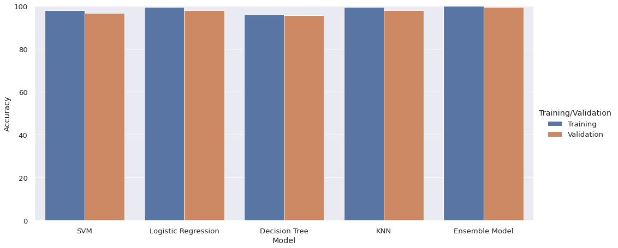

|  |  |  |
| --- | --- | --- |
| Model | Training Accuracy | Validation Accuracy |
| SVM | 98.0 | 96.75 |
| Logistic Regression | 99.67 | 98 |
| Decision Tree Classifier | 96.0 | 95.77 |
| KNN Classifier | 99.67 | 98.0 |
| Ensemble Model | 100 | 99.67 |

# Conclusion

In this paper, 5 classification models and 3 regression models have been proposed to

Customized machine and deep learning techniques can be utilized to categorize the assessment tools that could be regarded as the most precise ones to the least. In addition to these, they can help in discovering potential tools that may result in a better diagnosis which is inclusive of the further scope of our research. Unsupervised clustering techniques such as SOM can help in discovering latent clusters [18] that are likely to exist with a contemporary set of new common features that could be classified as LD.

In the manually proposed system, the informal educational assessment also measures other chief aspects such as the child’s sitting tolerance, attention levels possessed in the due course of the test, their ability to comprehend data, etc. Since the process now has been elevated to an automated level, it has noticeable and questionable gaps/ loopholes in the aforementioned aspects. Hence, the further scope of the project requires an incorporation of Sentiment Analysis from Video Capturing, Attention Detection, etc. on top of the current version of the project.

# Acknowledgement

We are extremely grateful to our course instructors for AI-ML Course – Dr. Vipul Kumar Mishra, Dr. Dilbag Singh, and Deep Learning – Dr. Apeksha Aggarwal for their continual mentoring and immense support all through the project duration. Their constructive criticism is what helped us bring about the desired result. We would like to acknowledge Ambitus International School, GIIS and Canary International School for giving access to their student archives. We would also like to acknowledge the Computer Science Department of Bennett University, our HOD Dr. Deepak Garg for providing us with the required resources and the right platform to develop and put forth our project and research.

##### References

1. Loizou, A., & Laouris, Y. (2011). Developing prognosis tools to identify learning difficulties in children using machine learning technologies. *Cognitive computation*, *3*(3), 490-500.
2. Margaret Mary, T., & Hanumanthappa, M. (2017). Hybrid classification approach hdlmm for learning disability prediction in school going children using data mining technique. *Journal of Theoretical and Applied Information Technology*, *95*(13), 2989-2998.
3. Margaret Mary, T., & Hanumanthappa, M. (2016). Effect of Feature Selection to Improve Accuracy and Decrease Execution Time with Predicating Learning Disabilities in School Going Children. *International Journal of Enhanced Research in Science Technology and Engineering*, *5*(3), 117-125.
4. Mary, M. (2013). EDUCATIONAL DATA MINING AND PREDICTION OF LEARNING DISABILITIES.
5. HANUMANTHAPPA, M. (2017). Intelligent And Effective Prediction System For Learning Disabilities In Children Using Data Mining Techniques.
6. David, J. M., & Balakrishnan, K. (2011). Prediction of learning disabilities in school-age children using SVM and decision tree. *Int. J. of Computer Science and Information Technology, ISSN*, 0975-9646.
7. Balakrishnan, J. M. D. (2010). Significance of classification techniques in prediction of learning disabilities. *arXiv preprint arXiv:1011.0628*.
8. David, J. M., & Balakrishnan, K. (2014). Learning disability prediction tool using ANN and ANFIS. *Soft Computing*, *18*(6), 1093-1112.
9. David, J. M., & Balakrishnan, K. (2013). Performance improvement of fuzzy and neuro fuzzy systems: prediction of learning disabilities in school-age children. *International Journal of Intelligent Systems and Applications*, *5*(12), 34.
10. Chakraborty, M. V. (2019). A SURVEY PAPER ON LEARNING DISABILITY PREDICTION USING MACHINE LEARNING.
11. Saraswathi, P., & Nagadeepa, N. (2018). Mining the Frequent Attributes Using Feature Selection Technique for Learning Disability Students.
12. David, J. M., & Balakrishnan, K. (2011). Prediction of Key Symptoms of Learning Disabilities in School-Age Children Using Rough Sets. *International Journal of Computer and Electrical Engineering*, *3*(1), 163.
13. Wu, T. K., Huang, S. C., & Meng, Y. R. (2006, July). Identifying and diagnosing students with learning disabilities using ANN and SVM. In *The 2006 IEEE International Joint Conference on Neural Network Proceedings* (pp. 4387-4394). IEEE.
14. Mounica, R. O., Soumya, V., Krovvidi, S., Chandrika, K. S., & Gayathri, R. G. (2019, July). A Multi-Layer Ensemble Learning Framework for Learning Disability Detection in School-Aged Children. In *2019 10th International Conference on Computing, Communication and Networking Technologies (ICCCNT)* (pp. 1-6). IEEE.
15. Hasseim, A. A., Sudirman, R., Khalid, P. I., & Tabatabaey-Mashadi, N. (2013). Comparison of ann and svm to identify children handwriting difficulties. *Engineering*, *5*(5), 1-5.
16. Sabu, M. K. (2015). A Novel Hybrid Feature Selection Approach for the Prediction of Learning Disabilities In School-aged Children. *International Journal of Artificial Intelligence & Applications*, *6*(2), 67.
17. Julie, M. D., & Kannan, B. (2010). Prediction of learning disabilities in school age children using decision tree. In *Recent Trends in Networks and Communications* (pp. 533-542). Springer, Berlin, Heidelberg.
18. Nugent, R., Ayers, E., & Dean, N. (2009). Conditional Subspace Clustering of Skill Mastery: Identifying Skills that Separate Students. *International Working Group on Educational Data Mining*.
19. Julie, M. D., & Kannan, B. (2012). Attribute reduction and missing value imputing with ANN: prediction of learning disabilities. *Neural Computing and Applications*, *21*(7), 1757-1763.